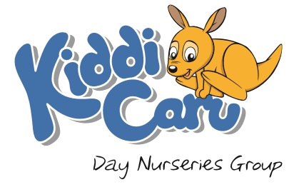
Self-Declaration Form
If you believe that you are a critical worker and/or your child meets the vulnerable category, we would be grateful if you could complete the following Self-Declaration and email to customerservices@kiddicaru.com no later than 7pm on Sunday 22nd March:
Nursery your child attends:
Your name:
Your Job Title:
Place of work:
Child’s full name:

